Patch Management Release 3.14
May 04, 2026

UI Enhancements
This section describes the UI enhancements introduced in Release 3.14.
ISL Module
- Rule-Based Automated Asset Isolation
PM Module
- Acquired From Vendor Patch Support
- Patching Support for Mac 26 on M5 Architecture
- New QQL Tokens
- Updated QQL Tokens

ISL Module
This section lists all the enhancements for the ISL module.

Rule-Based Automated Asset Isolation
Efficiently automate asset isolation using rule-based triggers in Vulnerability Management and Detection Response (VMDR).
Benefits:
- Reduce manual effort.
- Instantly isolates at-risk assets as soon as the condition is met.
- Accelerates response time to security risks.
- Strengthens your organization's overall security posture. This can be done by grouping your most critical assets and automatically isolating them when non-compliance or misconfiguration is detected.
To set Automated Asset Isolation and to know further, see Automate Asset Isolation.

This enhancement also adds the following activity logs in the Administration > Activity Logs tab:
- ISL request submitted: This log is generated when the targeted asset is isolated.
- Isolation request skipped as Asset not found: This log is generated when the asset for which the rule is triggered is not eligible for isolation.

PM Module
This section lists all the enhancements for the PM module.

Acquired From Vendor Patch Support
The vendor-acquired patches are now available on the VMDR > Vulnerabilities tab, and you can now directly create a Remediation job including these patches from VMDR. This includes both enabled and non-enabled vendor-acquired patches, allowing you to view patch coverage directly in VMDR.
Earlier, these patches had to be included in the job only through the Patch Management application, but with this enhancement, it is available on the VMDR > Vulnerabilities tab.
You can use the QQL token finding.isQualysPatchable: True on the VMDR > Vulnerabilities to fetch all the patches, including automatic and vendor-acquired patches.
NOTE: To create a Remediation job, ensure that vendor-acquired patches are enabled. Patches that are not enabled are indicated by a Lock icon; selecting these disables the Remediate Now option. For more information, see Enable Vendor Acquired Patches.
In the following image, the Unlock icon indicates the patch is enabled.
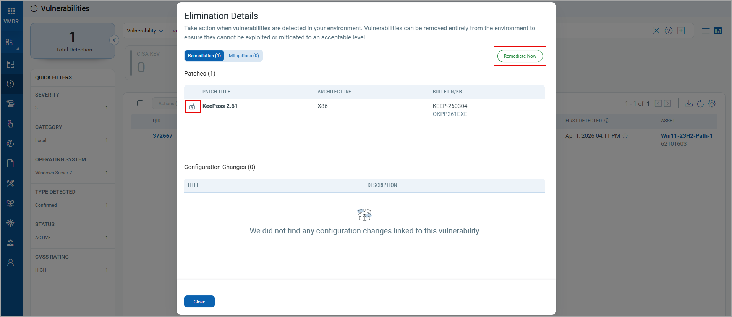The Lock icon indicates a non-enabled patch, as shown in the following image. Selecting a non-enabled patch disables the Remediate Now button.
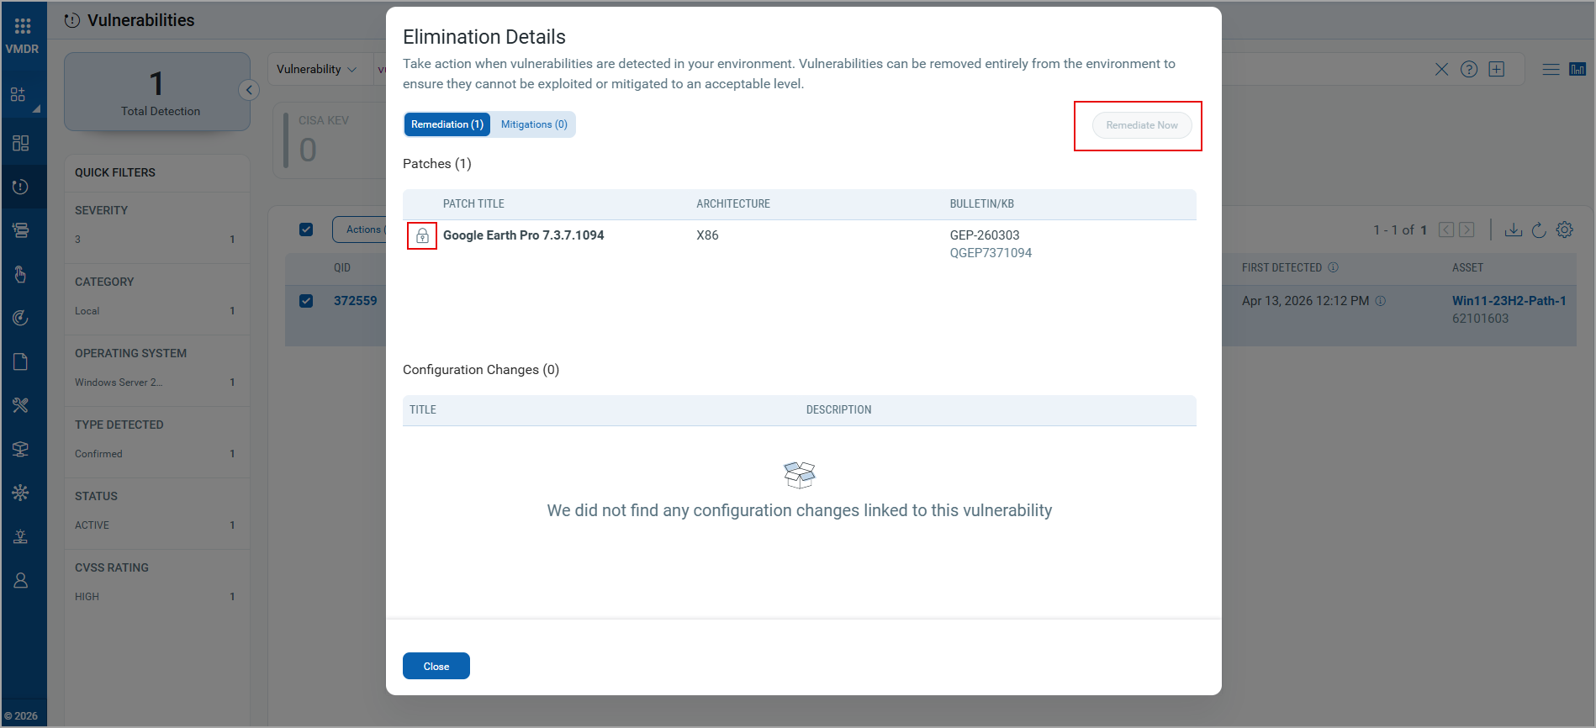

Support for Linux ARM Architecture Rollback Patching
With this enhancement, you can now perform patch rollbacks for Linux ARM architecture assets. To include the Linux ARM patches in a rollback job, in the Create Linux Rollback Job workflow, go to the Select Patches tab and use the QQL token “patch.architecture: aarch64” to filter the ARM patches.
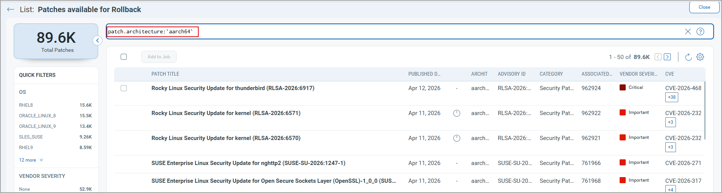

Patching Support for Mac 26 on M5 Architecture
You can now patch Mac 26 assets running on M5 architecture. You can filter these patches on the Patches listing page using the QQL token patch.supportedOs: `macOS 26 Tahoe` and patch.architecture: arm64`.

QQL Tokens
This section lists all the technical enhancements.

New QQL Tokens
Refer to the following table to learn more about the new token in this release.
Tab | Token (New) | Usage
- Jobs > Windows/Linux/Mac tabs  - Jobs > Create Job > Select Patches tab > Patch Selection from Another Job option > Select Job window  - Dashboard > Create Widget > Query Settings > Jobs > Windows/Linux/Mac | job.createdDate | To find the patch deployment jobs created as per the specified date or date range.

Updated QQL Tokens
Refer to the following table to learn more about the updated tokens in this release.

NOTE: Only the new tokens are displayed in the autosuggestion in the search bars within the UI. However, if you type the old token name manually, the QQL query still works. The old tokens do not appear in the autosuggestions on the UI.
The syntax and usage remain the same as for the old tokens.
Tab | Old Token | New Token
- Assets > Windows/Linux/Mac > Asset search bar  - Patches (Windows/Linux/Mac) > Asset search bar  - Patches > View Details page > Assets tab  - Jobs > Create Deployment Job (Windows/Linux/Mac) > Select Assets > Include Assets to this job > Search Assets windows  - Job Progress page  - Job Details page > Assets tab  - Aggregated Jobs Progress View page  - Reports > Create New Report > Windows/Linux/Mac > Asset search bar  - Assets > View Details > Patch Management tab > Select all filters > View All > Asset search bar  - Patches > View Details page > Assets tab  - Dashboard > Build your widget > Query Settings > Add Assets Query option | agent.id | qualys.agent.id
- Assets > Windows/Linux/Mac > Asset search bar  - Patches (Windows/Linux/Mac) > Asset search bar  - Reports > Create New Report > Windows/Linux/Mac > Asset search bar  - Patches > View Details page > Assets tab  - Dashboard > Build your widget > Query Settings > Add Assets Query option | sensor.activatedForModules | qualys.activatedForModules
- Assets > Windows/Linux/Mac > Asset search bar  - Patches (Windows/Linux/Mac) > Asset search bar  - Patches > View Details page > Assets tab  - Job Progress page  - Job Details page > Assets tab  - Reports > Create New Report > Windows/Linux/Mac > Asset search bar  - Dashboard > Build your widget > Query Settings > Add Assets Query option  - Assets > View Details > Patch Management tab > Select all filters > View All > Asset search bar | asset.lastLoggedOnUser | compute.lastLoggedOnUser
- Assets > Windows/Linux/Mac > Asset search bar  - Patches (Windows/Linux/Mac) > Asset search bar  - Patches > View Details page > Assets tab  - Job Progress page  - Job Details page > Assets tab  - Reports > Create New Report > Windows/Linux/Mac > Asset search bar  - Aggregated Jobs Progress View page  - Assets > View Details > Patch Management tab > Select all filters > View All > Asset search bar  - Dashboard > Build your widget > Query Settings > Add Assets Query option | asset.timezone | compute.timezone

UI Addressed Issues
The following reported and notable customer issues are fixed in this release.

Component/Category | Description
PM - Job Linux | An issue occurred in which, although email notifications were set in the Linux deployment job, the emails for the Execution Started and Execution Completed notifications were not received.  This issue is now fixed, and notification emails are received successfully.
PM - Job Windows | An issue occurred where if a deployment job is scheduled at a particular time that fell under the Daylight Saving Time (DST) transition gap, the job was stuck in the Prepared state.  This issue is now resolved, and the job runs at the scheduled time without getting stuck.
PM - Job Windows | An issue occurred when the acquired vendor patches from the VMDR > Vulnerabilities tab were used to create a remediation job. An error occurred while saving the job, and job creation failed.  This issue is now resolved, and we support creating remediation jobs for vendor-acquired patches from the VMDR > Vulnerabilities tab.
PM - Linux_Content | An issue occurred in which the patch published date for Linux patches was shown incorrectly on the Patch > View Details page. This issue is now fixed and the published date is correctly displayed.
PM - Job Windows | An issue was observed in which the Windows default deployment job did not trigger for the newly added asset. This issue is now resolved, and the default job runs on the newly added asset.
PM - Assets | An issue was observed where the missing patches were not displayed on the VMDR > Vulnerabilities > Actions > View Missing Patches. This issue is now fixed, and all the missing patches are displayed.
PM - UI | An issue occurred in which the failed deployment job actions and the pre- and post-action results were not displayed in the Job Results report. This issue is now fixed, and the job action results are displayed in the report.

If it is not an explicit ask from the client, I will add the API changes also under the same release highlight. The users can have a single document for a particular release, as one release version goes together with all the enhancements.

API Enhancements
This section describes the API enhancements introduced in Release 3.14.
- Acquired From Vendor Patch Support
- Isolate and Unisolate an Asset

Recommendation: Before you start using the APIs described in this release, we recommend reviewing the Know Your Qualys API Server URL section to identify the correct API server URL for your Qualys platform.

Note: Throughout this API Release Notes document, <qualys_base_url> is used as a placeholder in sample API requests. Replace it with the actual API server URL applicable to your account before making any API calls.

Acquired From Vendor Patch Support
The following API changes have been acquired from the vendor's patch support.

Updated API: Get Patch Insights Data
New or Updated API | Updated
API Endpoint | /pm/v1/remediation/insights
Method | POST
DTD or XSD changes | Not Applicable
We have enhanced this API to fetch the list of acquired vendor patches. The enhanced API includes a new parameter isCustomizedDownloadUrl, in the API response. If the patch for the specified QID is enabled, this parameter value is true; otherwise, it is false.

Sample - Get Patch Insights Data with Vendor Acquired Patches
//The API Request is mentioned perfectly, but I would add a Copy button on the top-right corner.//

//I would like to add a line after every H1, as in the API document, there is an H1, and immediately we have H2s.
The rest of the API content is perfect in Release 3.14, since the dropdown structure offers a better presentation. However, we'd like to add a copy option for API Requests, allowing users to easily copy and reuse them.

Isolate and Unisolate an Asset
The following API changes have been implemented for Isolate and Unisolate an Asset.

New API: Isolate and Unisolate an Asset
New or Updated API | New
API Endpoint | /isl/v1/assets/isolation/{action}
Method | POST
DTD or XSD changes | Not Applicable
We have introduced a new Isolate and Unisolate Assets API as part of automatic rule-based Isolation. These APIs help you to isolate or unisolate the assets in bulk using tags or individual assets using asset IDs. You must have the Isolation Manager and Isolation User roles to use this API.

